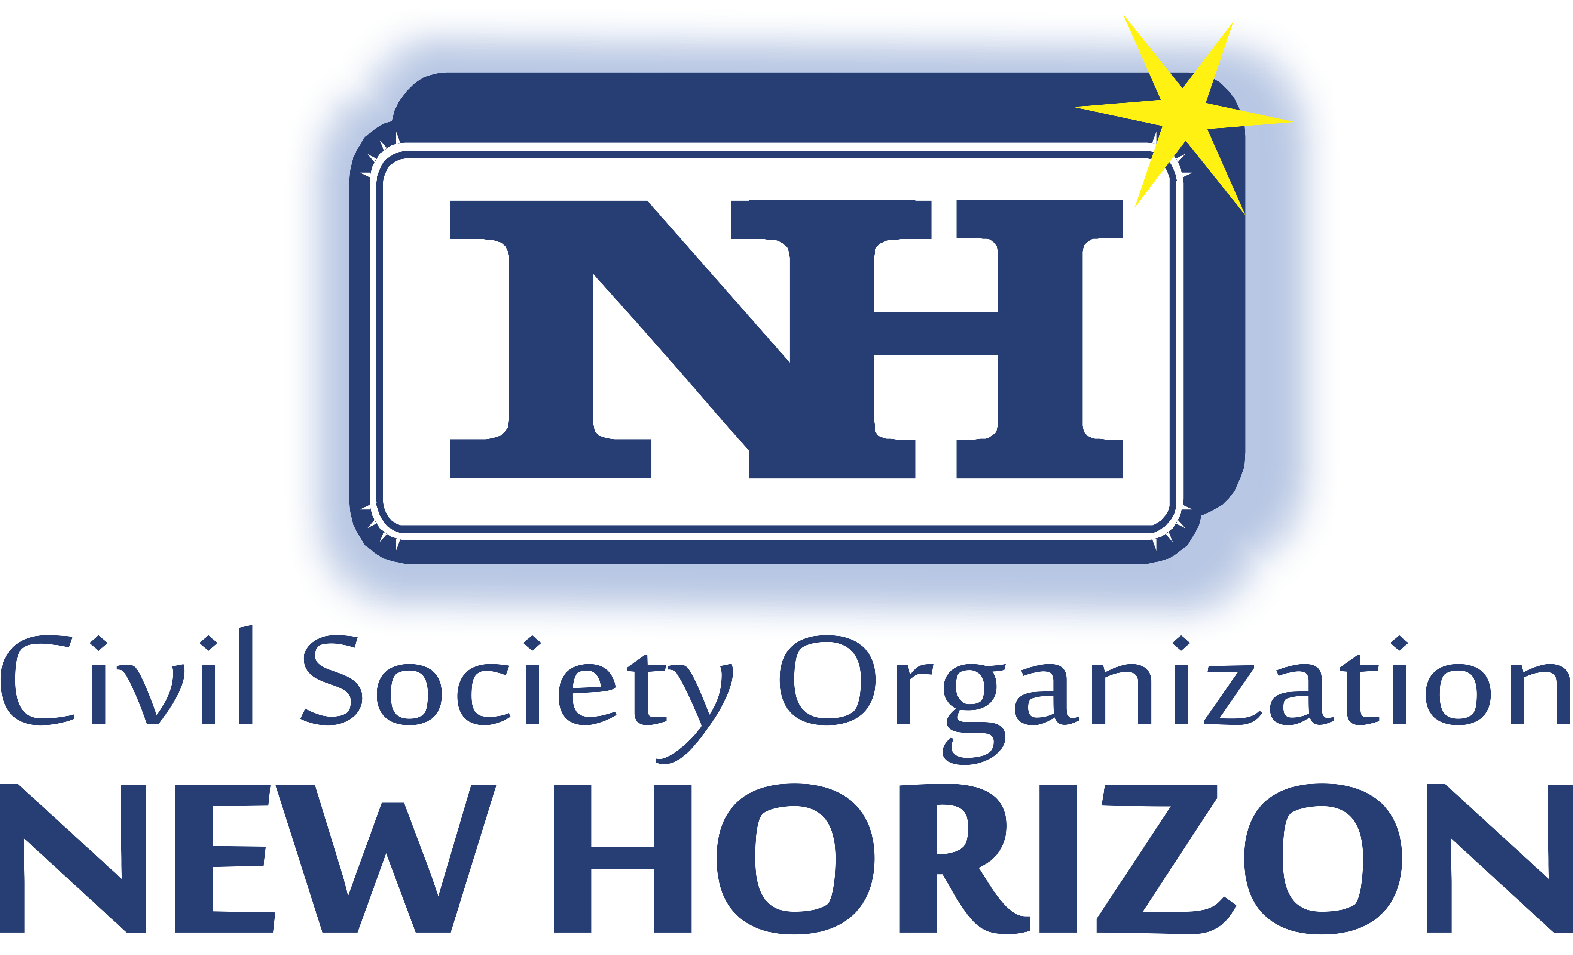

Terms of Reference for:
Service required on providing expertise in the design of a tailor made curricula about soft skills in tourism sector for youth in vocational education
March-2021
Service title | Soft skills curricula design with focus on tourism development for youth in vocational education.
Location/Country | Montenegro
Organization | New Horizon NGO
Project | Pathways to Career Development (PCD): Preparing Albanian and Montenegrin Youth for Career Opportunities in the Tourism Sector
Time frame duration | April-November 2021
Contract start date | April 15, 2021
Deadline for submission of bids | April 5th , 2021

Background information
New Horizon (NH) is a non-governmental organization founded in 1999 in Ulcinj, Montenegro. NH aims at increasing citizens’ participation in local processes and beyond, thus contributing to development of democracy and enhancement of good governance, through education and integration programs.
NH works on several areas: Women and Youth Program; Good Governance; Inter-Ethnic Dialogue and Civil Society Strengthening.
NH has the role of a Resource Centre for Civil Society Organizations in the local community, but also a ‘mediator’ between local government and state institutions with local NGOs. NH played an important role in drafting public policies of the Ulcinj Municipality, compiling 3 municipal action plans: Local Action Plan for Children, Local Youth Action Plan and the Local Plan for Fighting Addiction Diseases.
NH is working to strengthen the capacities of CSOs and local media in advocating public administration reform at the local level; to promote youth leadership and to strengthen inter-cultural dialogue among youth population. NH NGO conducts all its activities on a bilingual basis - Montenegrin and Albanian.

New Horizon NGO, World Vision Albania (as the Lead Applicant), Bratsvo Jedinstvo school from Ulcinj and Hamdi Bushati school from Shkodra are implementing the project “Pathways to Career Development (PCD): Preparing Albanian and Montenegrin Youth for Career Opportunities in the Tourism Sector” financed by Europian Union through the IPA II Cross-Border Cooperation Programme Montenegro – Albania 2014-2020. The target group of this project are 100 young people, especially from vulnerable groups, in Montenegro (Ulcinj) and Albania (Shkoder area) who are seeking employment or entrepreneurial opportunities as well as approximately 10 staff from professional schools in the same location. The Action will undertake job readiness (soft skills) training events and meetings based on youth needs (Activity 1.1.2). There will be organized 10 trainings for 50 youth on skills needed to prepare them for the job market upon a tailored shaped curricula with focus on tourism development through youth contribution.

Purpose of the Service

The expected results of the project are:
- Youth in the cross-border area of Montenegro and Albania are equipped with job readiness skills
2 - Youth in cross-border area of Montenegro and Albania explore new projects/ business ideas matching job market requirements;
3 - Youth exchange, share best practices and explore new cross-border activities.

The service required falls under result number one where it is expected to deliver job readiness (soft skills) training events. For this reason NEW HORIZON NGO is looking for an expert or team of experts to build/adapt the existing SKYE curriculum of New Horizon NGO in the format of ten training curricula where combining soft skills and principles of tourism sector development for 50 youth of ”Bratstvo-jedinstvo” school. After the expert/group of experts, design a tailor made curricula it is expected to deliver the trainings to 50 youth (divided in 2-3 groups respecting Covid 19 restrictive measures). The curricula should be interactive and appropriate for online and face-to-face meetings as well.

Responsibilities of the Contracted Experts:
- Review existing SKYE curricula of WVA who has a focus on youth employability; select and adapt literature for the purpose of this training;
- Develop a tailor made curriculum with ten training topics on soft skills focusing specially on employability and social entrepreneurship while combining them with key aspects of tourism development principles and approaches;
- Deliver 10 training sessions for 50 youth via online and face to face meetings.

Deliverables
In regard to the responsibilities above, the expert should submit by the end of the consultancy:

- The tailor made curricula – adaption of the SKYE curriculum (soft skills and tourism development) upon the ten topics to be delivered to youth;
- The agenda of the training and training materials;
- Facilitation guides for each training;
- Data Collection Tools (questionnaires and/or pre-post-test analysis analyzing knowledge gain of the participants);
- A report with key highlights from the training, successes and challenges from the process; included analysis from pre-post training; recommendations for the future to support the youth trained on their path to tourism development and employability.

Proposal / Documents required for submission

Please submit the following documents:
- A framework for a training session explaining the approach and typology of exercises / activities (soft skills for employability and social entrepreneurship).
- An expression of interest for the consultancy and sharing of roles and responsibilities of the group of expert/s members if applying more than one individual;
- CV highlighting the expertise of the applicants about soft skills trainings for employability, direct work with children and adolescents, previous expertise in trainings with youth, especially in the field of social entrepreneurship etc.; (Note: Given the specificity of the target group, knowledge of both local languages (Montenegrin and Albanian) is preferable but not mandatory.
- Previous references from other donors / agencies / organizations contacting the expert/experts will be considered an asset;
- A self-declaration regarding conflict of interest (stating that the expert/s has no conflict of interest from its employer etc. while delivering this consultancy);
- The consultancy fee in total including all applicable taxes as per Financial Offer Form attached to this ToR. (Note: Applicants shall calculate their own transportation means).
- Evidence of previous works resembling specifics in the ToR.
- Must be cleared of legal disputes that ended in Court in the past three years.
- References and / or sample of similar works
If you are a registered company / organization / agency, please also provide:
- Tax Registration number (PIB)
- Updated Extract generated from the National Registration Centre (CRPS)
- Provide last two years of audited financial statements or tax filing, or similar documents

General administrative information:
Technical proposal
In this part, the applicants will describe the approach and methodology for implementing the tasks. The proposal will include a statement outlining the rationale for the number and relevant experience of the experts that will be included for the service. Team composition and distribution of tasks should be a specific section of the technical proposal.

Financial Proposal
The applicants should provide a detailed budget for delivering all the tasks and activities foreseen in this call. The budget should, at least, distinguish between expertize days (fee days), and miscellaneous costs related with the preparation, presentation and printing of the final report.
*New Horizon NGO maintains the confidentiality of the offer and documentation you submit based on its strict procurement policies.

Final Evaluation and Award of Contract
The contract will be awarded to the best technically acceptable proposal considering proposed prices.

The following formula will be used for combined technical and financial evaluation of proposals:
The lowest evaluated Financial Proposal (Fm) is given the maximum financial score (Sf) of 100. The formula for determining the financial scores (Sf) of all other Proposals is calculated as following:
Sf = 100 x Fm/ F, in which “Sf” is the financial score, “Fm” is the lowest price, and “F” the price of the proposal under consideration.
The weights given to the Technical (T) and Financial (P) Proposals are:
T = 80, and
P = 20
Proposals are ranked according to their combined technical (St) and financial (Sf) scores using the weights (T = the weight given to the Technical Proposal; P = the weight given to the Financial Proposal; T + P = 1) as following: S = St x T% + Sf x P%.
Only Bidders that have passed the pre-qualification process of Technical and Administrative proposals will be considered for financial proposal evaluation.

Selection process
The proposals received will be evaluated according to the following criteria:
- Technical expertise as required in the ToR in the CV/s submitted (25 %)
- Tailor shaped curricula framework submitted as in the ToR described (35%)
- The time-length to deliver the service (15%)
- Quality and previous evidenced experience of working with youth employability, etc (25%)

Deadline for receipt of applications:
April 5th 2021
Questions/requests should be made by latest April 02, 2021 to the following e-mail address: nvohorizonti@t-com.me

APPLICATION PROCEDURE:
Bid submission end Date & Time
The deadline for submission of applications is April, 5th 2021, Hrs. 17:00. Applications should be sent by e-mail to the following address named “Soft skills Training Delivery and Facilitation” and name of the Expert.
nvohorizonti@t-com.me
NOTE: The Financial proposal and other required documents must be in PDF.
___________________________________________________________
Notes related to World Vision Albania & Kosovo Child and Adult Safeguard Policy:
All people working for World Vision Albania and Kosovo, or visiting its programmes are obliged to sign its Child and Adult Safeguard Policy and Behavior Protocols. This policy aims to create a child-safe organizational environment and is based on the principles of the UN CRC and its protocols.
Important note: The contract will be awarded to the winner upon submission of official documents that certify that the full team of the project – including field team – complies with the child protection rules and procedures. The selected applicant will be informed about the required documents before finalization of the contract.

Principles of child protection involve briefly but are not limited to:
- Treat children with respect and dignity
- Listen to children views and opinions
- Inform children parents/legal guardian/s and take a written consent before any interaction with children (this involves special written permission when it comes to photographs/videos)
- Be sensitive to the child age and maturity, cultural background and local social and family norms and respect them
- Dress in culturally appropriate way.
- Always be in the company of another adult (preferably parent/legal guardian or teacher) when meeting a child
- All visitors to WVA&K projects must be in accompany of WVA&K’s staff.
- Do not abuse with children (sexual, emotional, psychological and physical abuse).
*Please note that World Vision Albania and Kosovo personnel and visitors are expected to report any suspicions of child abuse to the National Director immediately. WV has policy and procedures that respond to accusations, which allows for a process that respects all involved. World Vision Albania holds the position that adults are always responsible for their behavior with a child, even if a child is acting seductively.

